**Pro UI Installation**

* Install the software using mytech.com.

1. Java 1.8 or greater
2. Node 4.47 or greater(Includes NPM also)
3. Git
4. Visual Studio Code

* Open the Git GUI

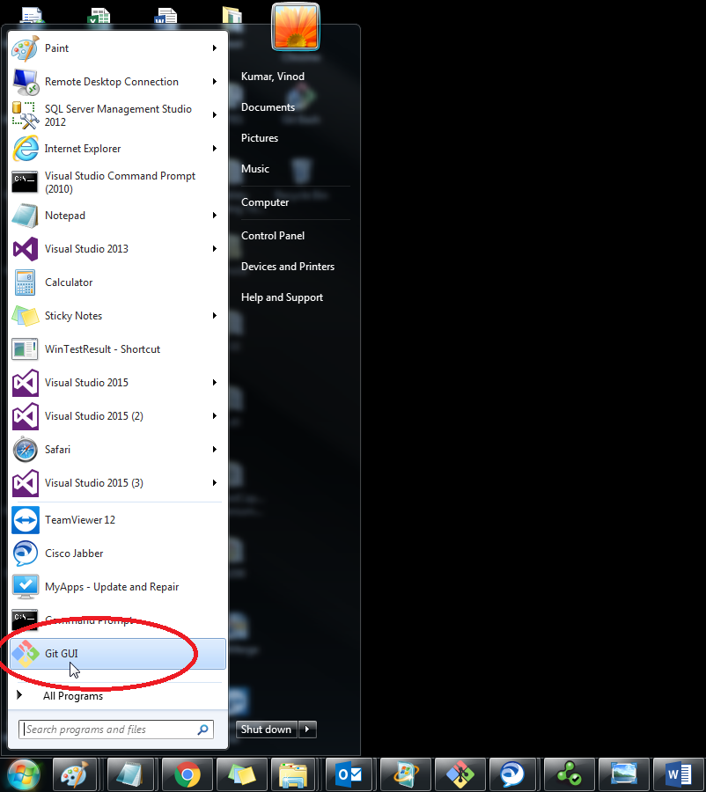

* Click on Create New Repository

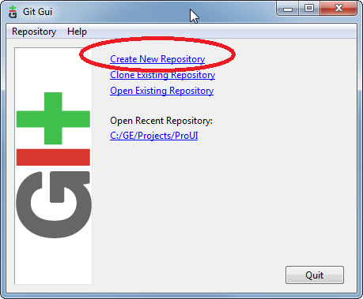

* Specify the directory location for repository and click on “Create” button.

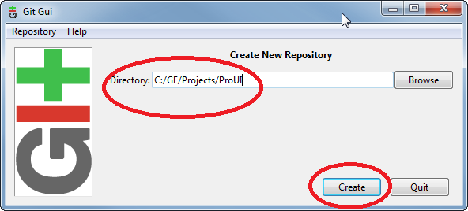

* Open the Repository menu and click on “Git Bash” sub menu.

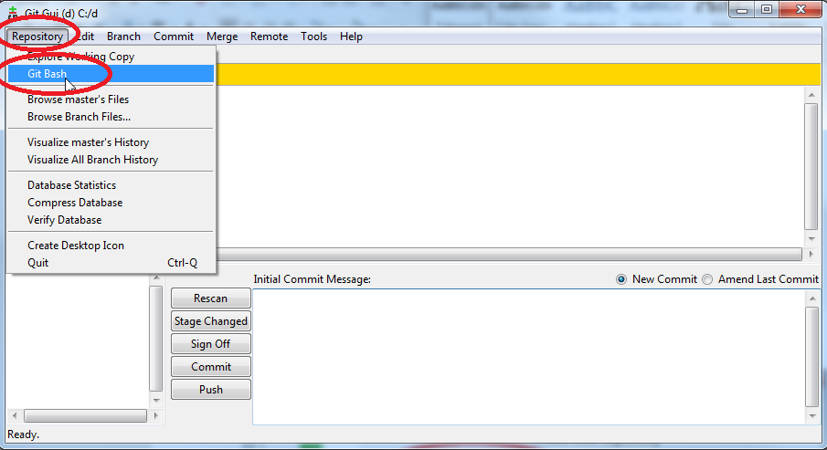

* Run the following commands.

**git config --global http.proxy http://127.0.0.1:31114**

**git clone https://github.build.ge.com/MicroTester/ProUI.git --branch ProUI_M**

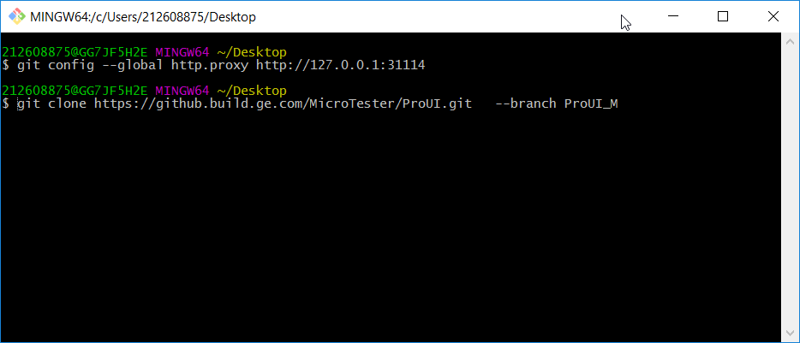

* Once the cloning is done you can see the confirmation message.

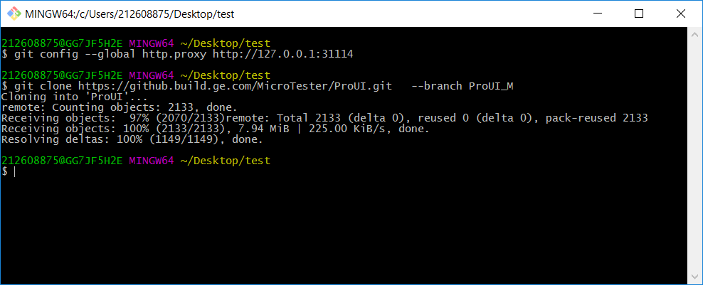

* Project will be downloaded in your local file system.

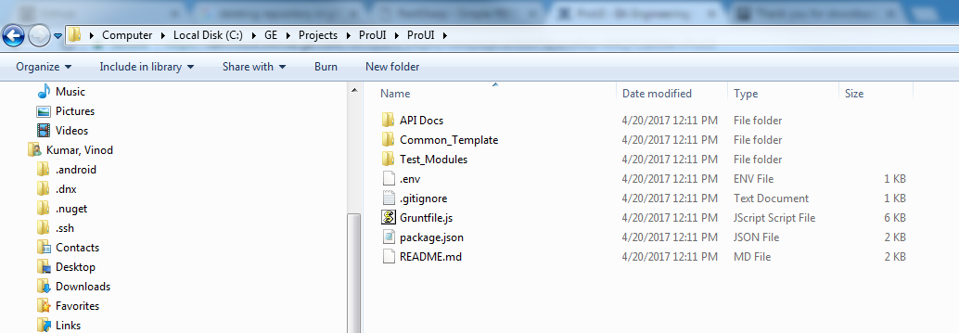

* Press **Windows + R** and type “Node”. You can find Node.js command prompt.

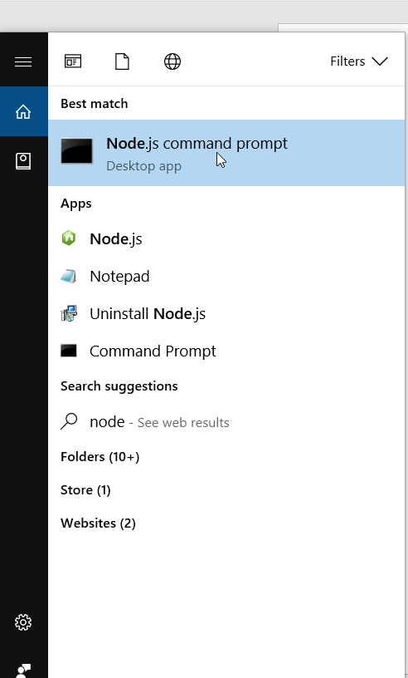

* Open the Node.js command prompt and run the following command

**npm install -g grunt**

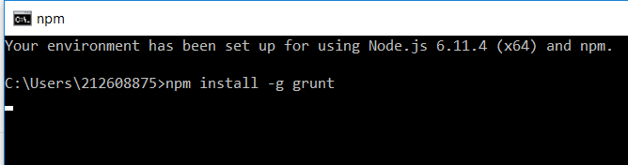

* Open the **Node.js** command prompt and navigate to Project root directory. Run the following command.

**npm install –save-dev**

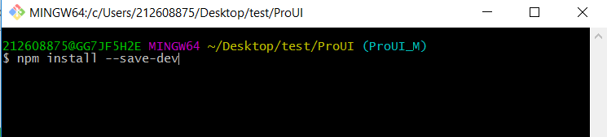

All the dependencies will be installed under **“node_modules”** folder in project directory.

* Open the **Node.js** command prompt and navigate to Project root directory. Run the following command.

**npm install –save-dev**

All the dependencies will be installed under **“node_modules”** folder in project directory.

* From same command prompt Run the following command.

**grunt test**

Selenium jar files and browser drivers will be downloaded.

* Open the **TestHelper.js** file located at **node_modules\proui-utils\Compressed_Utils.**
* Remove the highlighted **“new”** text from file and save it.

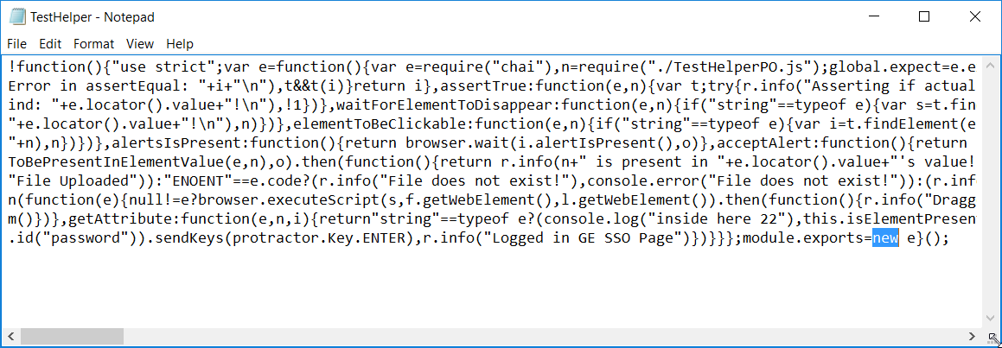

* Open project using Visual Studio Code. Click on **Debug** and **Settings** icon and select **Node.js** respectively.

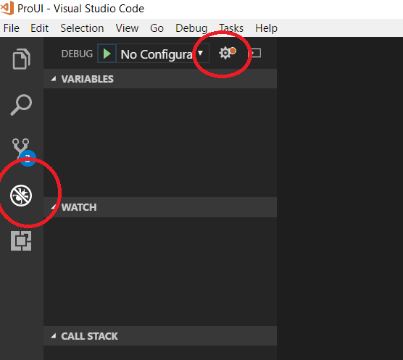

* You can see the **launch.json** file as below.

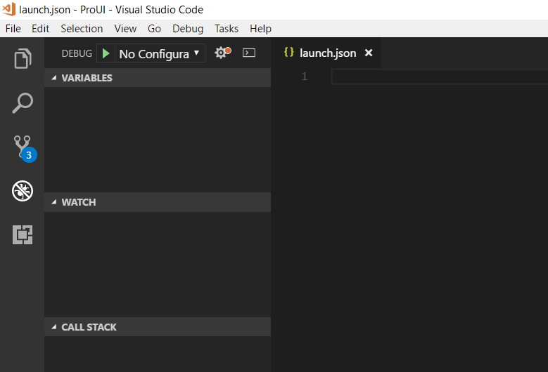

* Paste the following sample code in launch.json file to enable the debugging support for your respective projects.

{

"version": "0.2.0",

"configurations": [

{

"type": "node",

"request": "launch",

"name": "ProUI",

"program": "C:\\GE\\Projects\\ProUI\\node_modules\\protractor\\built\\cli.js",

"stopOnEntry": false,

"args": ["${workspaceRoot}/Common_Template/Conf/protractor.cucumber.common.conf.js","--suite","asset" ]

}

]

}

Yellow color highlighted text is project path specific to your system.

Blue color highlighted text is protractor config file path specific to your project.

* Save and close the launch.json file.
* You can select a specific configuration to debug your test cases.

